# Real City Mod Induction

Real City Mod Induction 1

1、Overview 2

2、Difference from original game 2

3、Detail information 3

3.1 Resident economic elements 3

3.1.1 Resident income 3

3.1.2 Resident expense 4

3.1.3 Resident consumption 4

3.1.4 Other resident behavior 5

3.2 Commercial and industrial building economic element 5

3.2.1 Building income 5

3.2.2 Building expense 5

3.2.3 Building behavior 6

3.3 Change in resident building and Office building 6

3.4 Player building 7

3.5 Change of outside connection 8

3.6 MOD UI 8

4、Summary 8

Appendix 8

# 1、Overview

The main purpose of RealCity Mod is to make game more reality like true world. It added several elements as below:

1. New citizen income and expense system.
2. New commercial and industrial income and expense system.
3. New city industrial chain system.
4. Dynamic city resident commercial industrial demand based on citizen and building economic situation.
5. Complex and dynamic outside connection.
6. Complex individual citizen and building behavior based on economic situation.
7. Plenty of new added city income and expense.

City income:  
New added personal salary-tax income  
New added industrial trade tax income  
New added outside garbage move demand income  
New added outside dead move demand income  
New added park and monument building tourist income  
New added feedthrough cargo truck road toll income  
New added garbage recycle center export product income  
New added outside crime move income (V0.2 not supported yet)  
New added outside sick move income (V0.2 not supported yet)  
Adjust fixed in-game land income (deeply decreased)

City expense:  
New added government employ salary expense  
New added electricity and heat and shelter material expense  
Adjust fixed maintain fee (decreased)

# 2、Difference from original game

Take city income and expense panel for reference:

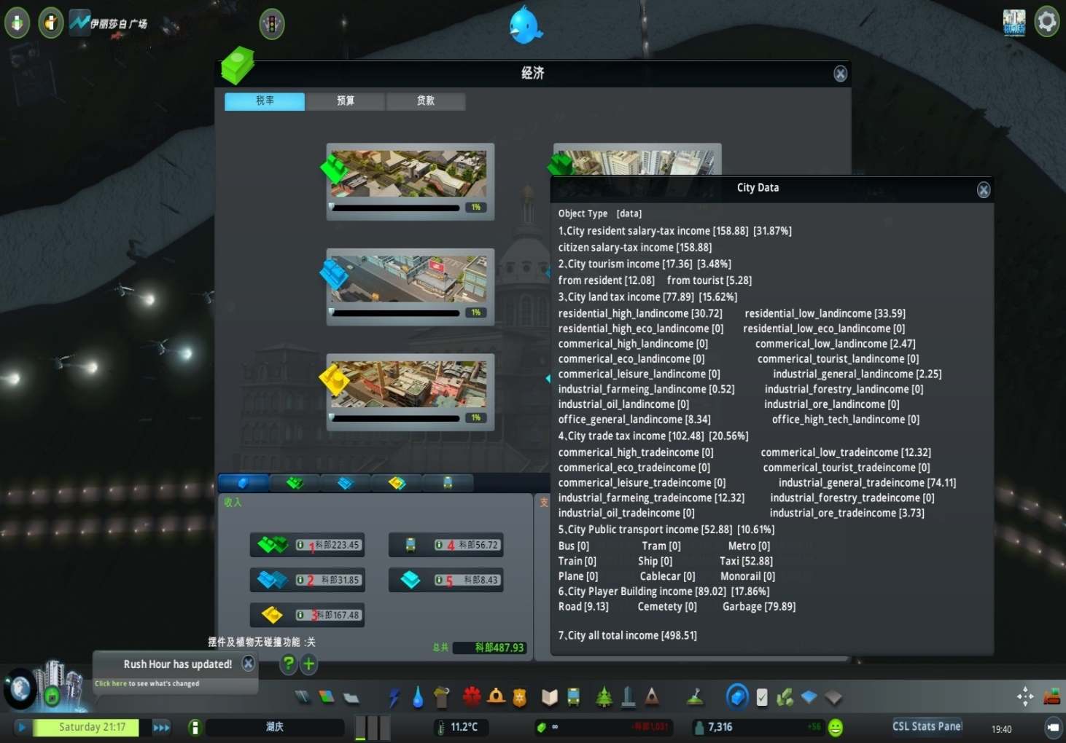

1. Residential building income（red marked point 1）is divide into two parts. Part1 is the same as original game(that is land income but significant decreased, shown in mod UI city land tax income). Part2 is new added (resident salary-tax income).
2. Commercial and industrial building income(red marked point 2、3) is divided by two parts. Part1 is the same as original game (that is land income but significant decreased). Part2 is tax income of building trade income(new added shown in mod UI city trade tax income).
3. In original game, tourist and resident income is just parts of commercial income and will not add into total count. in this mode, a new added city tourism income shown in MOD UI, which is park and monument visit income from both resident and tourist(added in commercial tourist in game UI).
4. No change for transport income（red marked point 4）
5. New added outside garbage deal、cemetery deal and road toll for feedthrough truck.
6. New added garbage recycle center product income
7. New added electricity and heat building expense for importing oil or coal.
8. New add employee salary in government building maintain fee (5-8 are all counted in maintain fee).
9. City resident commercial industrial demand will be based on citizen and building economic situation.

Compared with original game, which building land income is the most part of city income. In this Mod, plenty of new added income and expense is added to match the real word.

# 3、Detail information

## 3.1 Resident economic elements

1、Resident economic(calculate by family)contains income and expense. Some of (Income – expense) will be used as commercial consumption and replace original resident commercial consumption in game.

2、Income - expense - commercial consumption will be added as resident deposit. Resident with different deposit、income and expense will have different ideal about house choice, they will change their house or even leave city.

3、Every resident family will have their own income、expense and deposit.

### 3.1.1 Resident income

1、Resident`s income is related to their education and workplace. In generically, higher resident degree is with higher salary, higher workplace level is with higher salary.

2、Compared to real word, different career will get different salary. And if workplace building is not profit, salary will decrease a little.

3、Based on resident`s income, Excess Progressive of Tax Rate is used to get personal income tax and send to government as city income.

### 3.1.2 Resident expense

Resident`s expense contains home building expense、transport fee、education fee and hospital care fee.

#### 3.1.2.1 Home building expense

Home building expense is related to their building level and density and building land price. Lower density、higher land price and、higher building level will leads to higher home building expense.

Try to use tax to adjust resident home building expense.

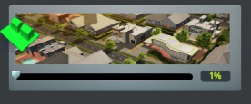

#### 3.1.2.2 Transport fee

Citizen transport fee is related to their transport vehicles and transport time. Using personal car、higher public transport ticket price、bad rood net or congestion will leads to higher transport fee.

#### 3.1.2.3 Education and hospital care fee

For each family, if there are students or sick person, some education and hospital care fee will be added into family expense.

### 3.1.3 Resident [consumption](http://www.so.com/link?url=http%3A%2F%2Fdict.youdao.com%2Fsearch%3Fq%3Dhousehold%2520consumption%26keyfrom%3Dhao360&q=%E5%B1%85%E6%B0%91%E6%B6%88%E8%B4%B9+%E8%8B%B1%E6%96%87&ts=1509613728&t=33fef4c3ad00be7bed2658f940e0a32)

Resident consumption is divided to two parts. Resident fixed consumption and Resident visit consumption.

#### 3.1.3.1 Resident fixed consumption

The rest money which resident income - tax - expense will be the standard for calculate resident fixed consumption. Resident will use some of the rest money to shopping in commercial building.

#### 3.1.3.2 Resident visit consumption

When visit commercial building or park or monument building, if resident have money, they will spend some money. When resident and tourist visit park or monument building, city will get some income.

### 3.1.4 Other resident behavior

#### 3.1.4.1Change house

If resident with high or low wealth, they will try to move to high or low level house.

If city can`t offer these houses, they will leave city.

#### 3.1.4.2 Impact on resident trip

If resident deposit is less than 0, they will not go to shopping or entertainment. They will not use personal car to travel. And they will not use or pay for public transport .

## 3.2 Commercial and industrial building economic element

There are also income and expense for commercial and industrial building.

1、Income – expense will be added into building deposit.

2、Every building will have their own income、expense and deposit.

### 3.2.1 Building income

Building income is depended on selling products, the selling products multiply products price is building income.

1、The more products exported outside the city, the lower price this product will be.

2、Building with higher level will get higher profit, and different subservice building will get different profit.

### 3.2.2 Building expense

Building expense is divided to 3 parts. Land fee、Employee fee and cost of importing products.

1、Land fee is deeply decreased and will be add into city income.

2、Employee fee is 3.1.1, resident income.

3、The more products import outside the city, the higher price this products will be, higher level building will get lower income products price.

Try to use tax to adjust building expense.

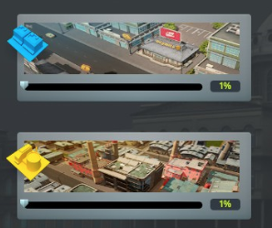

### 3.2.3 Building behavior

1、Each building income multiply tax rate will be added in city income. Building which is losing money in a long term will be down.

2、Building detail info will be shown in building UI. There will be a no custom tag on building that is losing money(<-3000).

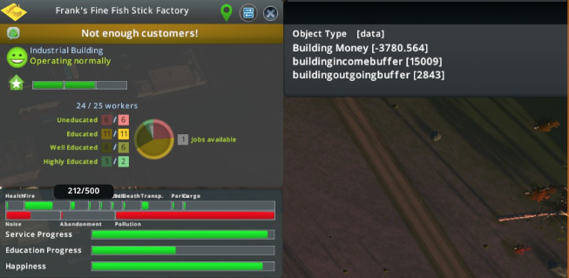

## 3.3 Change in resident building and Office building

1、Deeply decrease resident building land income for city(compensate by resident income tax)

2、Office building will not produce goods now, and have high salary and high land income. But if there is not enough profit industry building, and if there is not enough highly or well educated citizen, office building salary and land income will decrease.

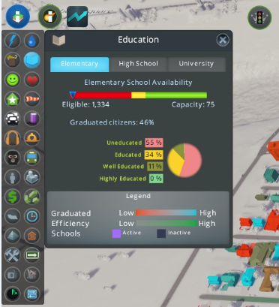

## 3.4 Player building

1、This mod add employee fee in player building expense, while decrease maintain fee compared with original game .

2、Electivity and Heat building may import oil or coal, this will cost some city money.

3、Recycle Garbage building will produce some goods, which can be count into city income.

4、Park and Monument building visited by resident or tourist will count into city income, but resident with deposit less than 0 will not spend money on it.

5、There are garbage move or dead move(new added) from outside to our city, this will add some money to our city.

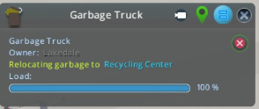

6、With road main building, cargo which travel though city will give some money to city.

7、With police station, sometimes there will be crime move from outside to our city, this will add some money to our city. **(V0.2 not supported)**

8、With hospital, sometimes there will be sick move from outside to our city, this will add some money to our city. **(V0.2 not supported)**

## 3.5 Change of outside connection

1、Resident、commercial and industrial demand is now based on their economic situation

2、Outside situation may change in a period, export-oriented city may come into a tough situation.

*red marked is not supported in current version

## 3.6 MOD UI

1、Debug UI, which contains lots of economic element, use CTRL+M to call it.

2、Income UI, contains all kinds of income, use CTRL+R to call it.

3、Building info UI, only show commercial and industrial building money, incoming buffer and outgoing buffer. Just click building and this UI will show on the screen.

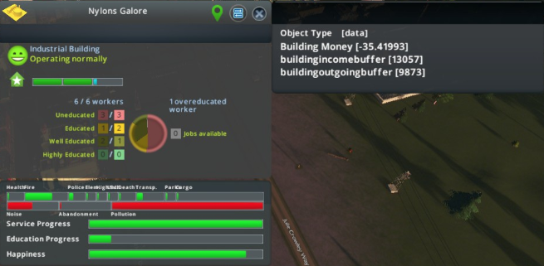

# 4、Summary

With all these new feathers, just try to manage a city like a real world.

# Appendix

Debug UI (ctrl + M) introduction：

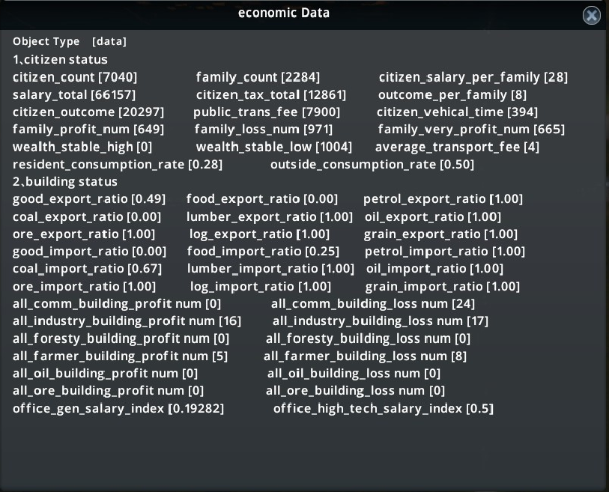

1、citizen_expense current citizen house rent + education and hospital fee

2、public_trans_fee resident current public transport fee

3、citizen_vehical_time resident current travel with car time

4、average_transport_fee resident average transport fee with 2 and 3

5、1 and 4 compared with resident salary stands for current resident economic situation.

6、family_*_num citizen income – house rent and education states, > 30 very profit < 0 loss money

7、wealth_stable_* resident wealth in long term, wealth_stable_high resident will try to change house to level 4 and 5, low resident will try to change house to level 1 and 2

8、outside_situation outside economic situation（0.2version not supported）

9、*ratio product import or export ratio, will affect industrial profit

10、all*building*num economic situation on buildings, if profit building is less than loss money building, demand will be 0.

11、office_salary_index, with not enough industrial building, office salary and land income will decrease.